Name:
Date:
Period:
Clothing Care Quiz
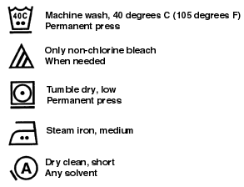
Directions: Use the care label provided to answer the following questions.

- What might this piece of clothing be made from?

- How would you advise the owner to dry the piece of clothing?

- Explain why different colored spots have appeared on the piece of clothing AND possible ways to fix the piece of clothing.
Directions: Use to care label to answer the following questions. If the question cannot be answered using the care label write "not enough information".
A. What solvents should be used to dry clean?
B. What setting should the iron be set on?
C. What other colors can be included when washing?

Name:
Date:
Period:
Food Label Quiz:
Directions: For this exercise, use the box of Cheerios with Nutrition Facts sheet. Using the information given to you on this page, answer the following questions in FULL SENTENCES. Be sure if the question is a two-part question you answer BOTH parts.

- There are several claims relative to health on the Cheerios box. Name three of them.

- Is this food a good source of Iron? Why or why not?

- Is the serving size a realistic representation of what the average person would eat at one sitting? Why or why not?

- If you had a bowl of Cheerios, is it likely that the calories listed on the label for one serving would accurately reflect your calorie intake? Why not?

Name:
Date:
Period:
Parenting Styles Quiz

Directions: Use the scenario below to answer the following questions.
Morgan is a 3 year old who recently started a new daycare. Her parents shower her with love and affection. At daycare one day, Morgan grabbed a toy from her playmate, but her parents chose to not intervene. Her parents believe Morgan should be allowed to express herself. Her parents also believe that it is ok because it is Morgan’s toy in the first place so she doesn’t have to share if she doesn’t want to. When Morgan requests extra snacks, her parents give her more food without hesitation. Her parents let her eat anything and everything she wants without limits or restraints.

- What type of parenting style do Morgan’s parents follow? Which parenting style is recommended as the “best”?

- What could Morgan’s parents have done differently to aid in providing freedom while setting limits?

- What is wrong with Morgan’s parents’ style of parenting? What complications could this style of parenting cause later in Morgan’s life?

- After reading this situation, do you think Morgan’s parents practice effective discipline? What are some characteristics of effective discipline?

Name:
Date:
Period:
Childhood Nutrition Quiz

Directions: Read each of these scenarios below. Utilizing the chart given to you, answer each question completely through short answer response.
- You are a parent raising a two year old child. What foods would you include in a grocery list to ensure that your child is eating a healthy diet? The grocery list is for one day of foods for the child. You must include the correct portion sizes and all food groups and differentiate the foods you are buying and their corresponding meals. ( 1 point)

- You are a parent raising a four year old child. When you took her to the doctor and she found out she was low in iron and calcium nutrients. What foods would you include in a grocery list to ensure that your child is eating a healthy diet? Specify the foods that would help raise your childs iron and calcium levels. The grocery list is for one day of foods for the child. You must include the correct portion sizes and all food groups and differentiate the foods you are buying and their corresponding meals. (2 points)

- You are a parent raising a three year old child who she is an extremely picky eater. She will only eat peanut butter and jelly sandwiches. What food groups and nutrients is she missing in her diet? What are some techniques you can utilize to promote healthy eating habits and a variety of food groups for your child? (2 points)

Name:
Date:
Period:
Drug Education

Directions: Read the paragraph below describing a scenario relating to topics we have studied in this unit and answer the following questions to the best of your ability using full, complete sentences.
Jeremy is a junior in high school and was always being teased about his skinny body. This bothered Jeremy a great deal as he was tired of wrestling only scrawny freshmen who were much younger than him. At the beginning of the school year, Jeremy decided to do something about his skinny stature. At the advice of his wrestling buddies he decided to take a shot to help him bulk up. Pretty soon Jeremy was shooting up every week and he started to notice muscle gain almost immediately. After a month of use, Jeremy begins to hallucinate frequently and also have mood swings that have begun to affect his relationship with his family and friends. After three months of use, Jeremy faints during his history class. He wakes up in the hospital to find that he has suffered a minor stroke.

- Based on the information given, what drug has Jeremy been using?

- What alternatives to drug use could Jeremy could have used in his situation?

- Jeremy suffered from hallucinations and mood swings. Name four major side effects that Jeremy could have exposed himself to while using this drug?

- If Jeremy were your friend, what advice would you give him regarding his drug use? What is your reasoning for this advice?

Quiz 1 Key:
- Cotton
- Air dry/ tumble dry
- Bleach was used, use more bleach to decorate the shirt, use a marker/ fabric paint.
- Any, Medium setting, not enough information provided.
Quiz 1 Objectives:
List points to remember in washing, drying, and pressing clothing.
Describe simple clothing repairs.

Quiz 2 Key:
- Good source of fiber; one gram of sugar; 100 calories per serving
- One serving contains 50% of the RDA of iron—yes, it’s a good source.
- The serving size listed on the Cheerios label is 1 cup. Few people actually measure their cereal portions out; many have 1 ½ cups or more per serving. In addition, the milk amount is listed as only ½ cup, also rarely measured accurately at the breakfast table.
- Only a small percentage of people use skim milk with their cereal. The calories listed do not take into account the additional calories in 1%, 2% or whole milk, nor does the calorie count allow for things that the consumer might add to the cereal, such as sugar or sliced banana.
- 420 mg—about 30% of the RDA
- The statement uses a serving size other than that which the nutritional information is based on; it is highly unlikely that a person is going to eat two meal a day of Cheerios for six weeks (bleah!); the bad cholesterol reduction touted in the claim was only “about 4%”, and this was in conjunction with “a diet low in saturated fat and cholesterol”. It’s quiet possible that the “diet low in saturated fat and cholesterol” by itself could be responsible for a 4% reduction in bad cholesterol.

Analyze nutritional data.
Assess the influence of socioeconomic and psychological factors on food and nutrition and behavior.
Analyze recipe/formula proportions and modifications for food production.
Critique the selection of foods to promote a healthy lifestyle.
Quiz 3 Key:
- The type of parenting style Morgan’s parents are demonstrating is permissive. The parenting style recommended by specialists in Authoritative.
- Morgan’s parents should have explained to Morgan that taking toys from friends in wrong and that it is important that we share with our friends. They need to show Morgan how to respect her friends.
- Permissive parenting allows children too much freedom and can cause behavioral issues. Children that are raised from permissive parents are likely to feel insecure because they have no boundaries. They usually are self-centered and uncooperative. They also are more likely to face difficulties as adults with social conventions.
- No, encourage positive behavior and discouraged negative behavior. Set reasonable limits, Use positive reinforcement, and be consistent.
Quiz 3 Objectives:
- Students will describe the vital role parents play in their child’s development.
- Students will explain effective methods of discipline and punishment.
- Students will distinguish between the different parenting styles and determine which styles is recommended.
Quiz 4 Key:
- Breakfast: 1 c. apple juice, 1 slice toast, 1 T. Peanut butter
Lunch: 1/2 c. chopped carrots, 1 c. milk, 2 slices of bread, 1 oz turkey
Dinner: 4 oz yogurt, 1 cheese stick, 1 ear of corn, and 1 oz chicken

- Breakfast: 1 c. milk, 1 scrambled egg, 1 Tbsp peanut butter, 1 slice bread
Lunch: 4 oz yogurt, 2 oz ground meat, one tortilla, 1 c. apple juice, 2 cups leafy vegetables
Dinner: 1 c. milk, 1 cheese stick. 2 oz turkey, 4-5 large strawberries, 2 slices bread, 1 cup chopped carrots

Iron: Ground beef, turkey
Calcium: Milk, yogurt, cheese

- You are a parent raising a three year old child who she is an extremely picky eater. She will only eat peanut butter sandwiches. What food groups and nutrients is she missing in her diet? What are some techniques you can utilize to promote healthy eating habits and a variety of food groups for your child? (2 points)

- Vegetables, dairy, fruits
- Iron, calcium, vitamin C

- Kids like to try foods they help make. Children also learn about fruits and vegetables when they help make them. And all of that mixing, mashing and measuring makes them want to taste what they are making.
- Offer choices. Rather than asking "Do you want broccoli for dinner?" ask “Which would you like for dinner: broccoli or cauliflower?”
- Offer a variety of foods and let your child choose how much of these foods to eat.
- Offer the same foods for the whole family. Don't be a “short-order cook,” making a different meal for your preschooler. Your child will be okay even if they don't eat a meal now and then

Quiz 5 Key:
- Anabolic Steroids
- Jeremy could have used better diet and exercise practices. (Also accepted: Jeremy could have attempted to be the best he could possibly be in his weight class.)
- Liver damage, extreme acne, major heart damage leading to heart attacks, high blood pressure, infertility, major hormonal imbalance

Quiz 5 Objectives:
7.4.1 Assess health, wellness, and safety issues of individual and families with a variety of disadvantaging conditions.
7.4.2 Analyze management and living environment issues of individuals and families with a variety of disadvantaging conditions.
7.4.3 Analyze personal, social, emotional, economic, vocational, educational, and recreational issues for individuals and family with a variety of disadvantaging conditions.

7.4.4 Discriminate between situations that require personal prevention or intervention and those situations that require professional assistance.

7.4.5 Analyze situations which require crisis intervention.

7.4.6. Summarize the appropriate support needed to address selected human services issues.

Handouts for the students:
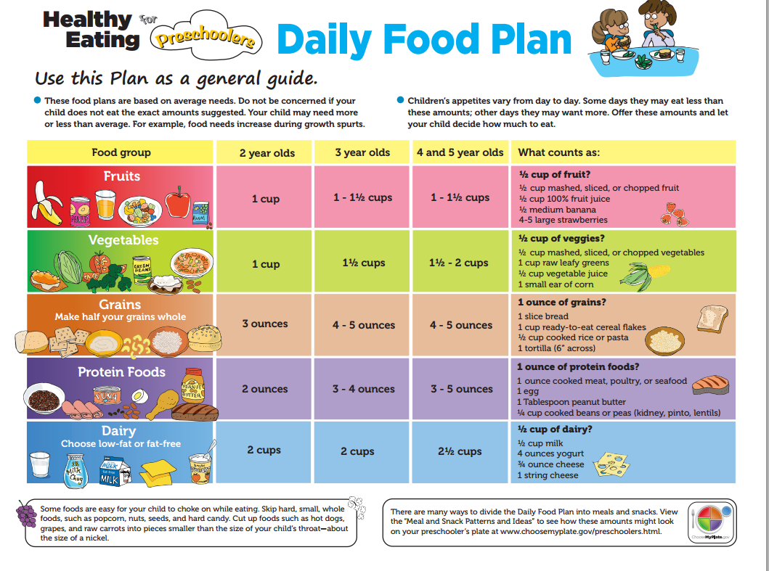

Quiz 2 Objectives:

